# **Hakai Institute Research Catalogue and Data Packaging Guide**

**Please make a copy of this document before filling in the following information for your dataset and return this form, along with the zipped data package to** [catalogue-team@hakai.org](mailto:catalogue-team@hakai.org)

Hakai Institute is a rapidly growing organization with a data collection as varied as it is large. A truly comprehensive research catalogue should include sometimes overlooked but vital supporting documentation and detail. Our goal is to populate the [Hakai Metadata Catalogue](http://hecate.hakai.org/geonetwork) with ancillary information, which will help enable us to inform Hakai researchers, affiliate collaborators, community partners, and the general public. We encourage all initiatives to submit records of their work, including long-term monitoring and short-term experiments. Protecting sensitive data is something we take seriously and will work toward this where required.

An organized and complete research catalogue is the backbone of long-term ecological research. Please help us to better document Hakai research, build partnerships between research disciplines, and inform the greater scientific community of our work.

Requirements for the contents of your data package:

1. Create a README.txt file to: 1) orient users with the contents of your data package; 2) Describe thoroughly the field, lab, and data processing protocols used to produce your data; 3) Make dependencies and software requirements for opening your data or scripts explicit; 4) Provide any additional information that you deem useful such as links to literature referenced, equipment manuals, or spatial extents of sampling.
2. Create a ‘DATA DICTIONARY’. This describes each variable in every table of your data package. Include variable name, units, description. Recommended format: .**csv** or .**txt**
3. If updating an existing data package (because you are adding new data, or correcting errors), create a CHANGELOG.txt to keep track of what changes or additions have occurred since the last version. Follow [this guide](https://keepachangelog.com/en/1.0.0/) to keeping a changelog.
4. Save all your data tables as **.csv** files.
5. Put all files into a folder and name the folder after your ‘Dataset-Title’ (should be the same name you enter for ‘Dataset Title’ below).
6. To create a new version of a data package, zip all files and store them in a sub-folder of the ‘Dataset-Title’ folder and name the folder after the new version of the data package.

Optional:

* Include scripts that were used to clean or process data from the raw data, calculate values in the final data package, or that join data tables for common views.
* Include in your readme a link to the GitHub repository that you might be using to track changes of your project, including specific commits or releases that match the versioning used in a changelog.
* If your data package has numerous tables in a relational database structure, include a diagram describing relationships of tables such as an Entity Relationship Diagram.
* List all investigators involved in the creation of the dataset.

See an [example data package here](https://drive.google.com/drive/folders/1HSnsnORC_Sy-kqLhnIVMKdDSj2aWEvHX?usp=sharing).

**Catalogue Entry Form**

[Click here to view an example completed form.](https://docs.google.com/document/d/1ALsUvwzWzNImg_9w4jX9mp0e6eeuHZcbaR5HtZsgBDw/edit?usp=sharing)

**Dataset Title:**

**Topic – Location – Date(s) if applicable). Example: Jellyfish-Monitoring-Study–Pruth Bay, Calvert Island–September-2016. Try to avoid acronyms.**

|  |
| --- |
| **Seagrass Fish & Macroinvertebrate Diversity and Abundance - Central Coast, BC** |

**Point of contact information:**

**Name - research institution - email**

|  |
| --- |
| **Zachary Monteith - Hakai Institute -** [**zach.monteith@hakai.org**](mailto:zach.monteith@hakai.org) **Margot Hessing-Lewish – Hakai Institute – margot@hakai.org** |

**How the data should be cited:**

Example: (Evans, W., A. Hare, and K. Pocock. (2017). High-resolution record of surface seawater CO2 content from December 2014 to April 2016 collected in Hyacinthe Bay, British Columbia, Canada. Version 1.0. Hakai Institute. Dataset. [access date].)

|  |
| --- |
| **Monteith Z.L., Manning F.S., Olson A.M., and Hessing-Lewis M. (2022). Seagrass subtidal fish and macroinvertebrate survey data from BC Central Coast. v1.1.0. Hakai Institute dataset. [access date].** |

**Description / Abstract:**

**A simple, easy to read description of what the dataset is.**

|  |
| --- |
| **The Seagrass Fish & Macroinvertebrate dataset is a component of Hakai Institute’s Nearshore research and monitoring program, designed to determine the drivers of change in seagrass ecosystems. The overarching objective of Hakai Nearshore research is to investigate the role of habitats and their associated communities, in the face of stress and disturbances from global climate change and local coastal perturbations.**  **This data package contains fish and macroinvertebrate observations collected from February 2019 to August 2022, at long-term seagrass meadow monitoring sites on British Columbia’s Central Coast. SCUBA divers collected data from 6 sites annually and 2 sites seasonally along permanent 30m transects. Fish and macroinvertebrate data were collected concurrently; 2 fish surveys were conducted alongside 2 macroinvertebrate surveys (one for all macroinvertebrates and one for *Cancer* crabs and bivalve siphons only). The data files included in this data package are: 1) ‘Fish’ surveys, containing fish observations, and 2) ‘Invertebrate’ surveys, containing macroinvertebrate observations. Species, abundance, and estimated size were recorded for all observations. Data included here are a subset of the Hakai Institute’s seagrass monitoring dataset.**  **This Hakai data package is freely available to everyone, following the principles of equitable access and benefit sharing. However, creating data packages cannot happen without the contribution of many scientists and data managers involved with science coordination, data aggregation, quality control, and data management. Therefore, we expect all data users to give attribution to the data providers (see README and LICENSE within package contents for further details) and the use of data from Hakai Nearshore should happen in the light of fair use, ie.:**   * **Respect the data providers, and provide helpful feedback on data quality** * **Communicate and/or collaborate with Hakai Nearshore researchers if you are considering using this dataset for manuscripts, or other forms of reporting.** |

**Data Type:**

**Format: TXT / SHP / CSV / XLSX / WORD / LAS / etc.**

|  |
| --- |
| **CSV** |

**Spatial Coverage Description:**

**Geographic description of the area covered in this study? Example: Coastal area between Triquet Island and Spider Island – BC – Central Coast.**

|  |
| --- |
| **Subtidal and intertidal seagrass beds at 6 survey areas between Calvert Island and the McMullin Group - BC - Central Coast** |

**If it is a geospatial dataset please state coordinate system used:**

|  |
| --- |
|  |

**Temporal Coverage:**

**When was the data collected? Example: July 21st 2016 to August 10th 2016.**

|  |
| --- |
| **February 2019 - August 2022** |

**External links or resources to include in the record**

**Metadata records / applicable documents / google drive folders.**

|  |
| --- |
| [**Hakai Seagrass Protocol**](https://docs.google.com/document/d/1zu3VtYDs9tAC3tl4i40-v1tgt3VMOeNs0hozBY44sr8/edit?usp=sharing) |

**Keywords**

**List keywords that describe your dataset (4-7 is ideal). Example: Oceanography, CTD, conductivity, temperature, salinity, depth, Calvert Island, coast, ocean, water, sample, plankton, chlorophyll.**

|  |
| --- |
| **Eelgrass, *Zostera marina*, subtidal, LTER, fish, macroinvertebrate, diversity, abundance, size, SCUBA** |

**Data Accessibility - Public or Private**

**Specify if you would like your data to be downloadable (public) / available to Hakai researchers internally / archived with individual researcher (privately held).**

|  |
| --- |
| **Available to the public upon request** |

**Record Thumbnail Image**

**If you have a square thumbnail image that well represents this dataset please provide it along with this metadata sheet.**

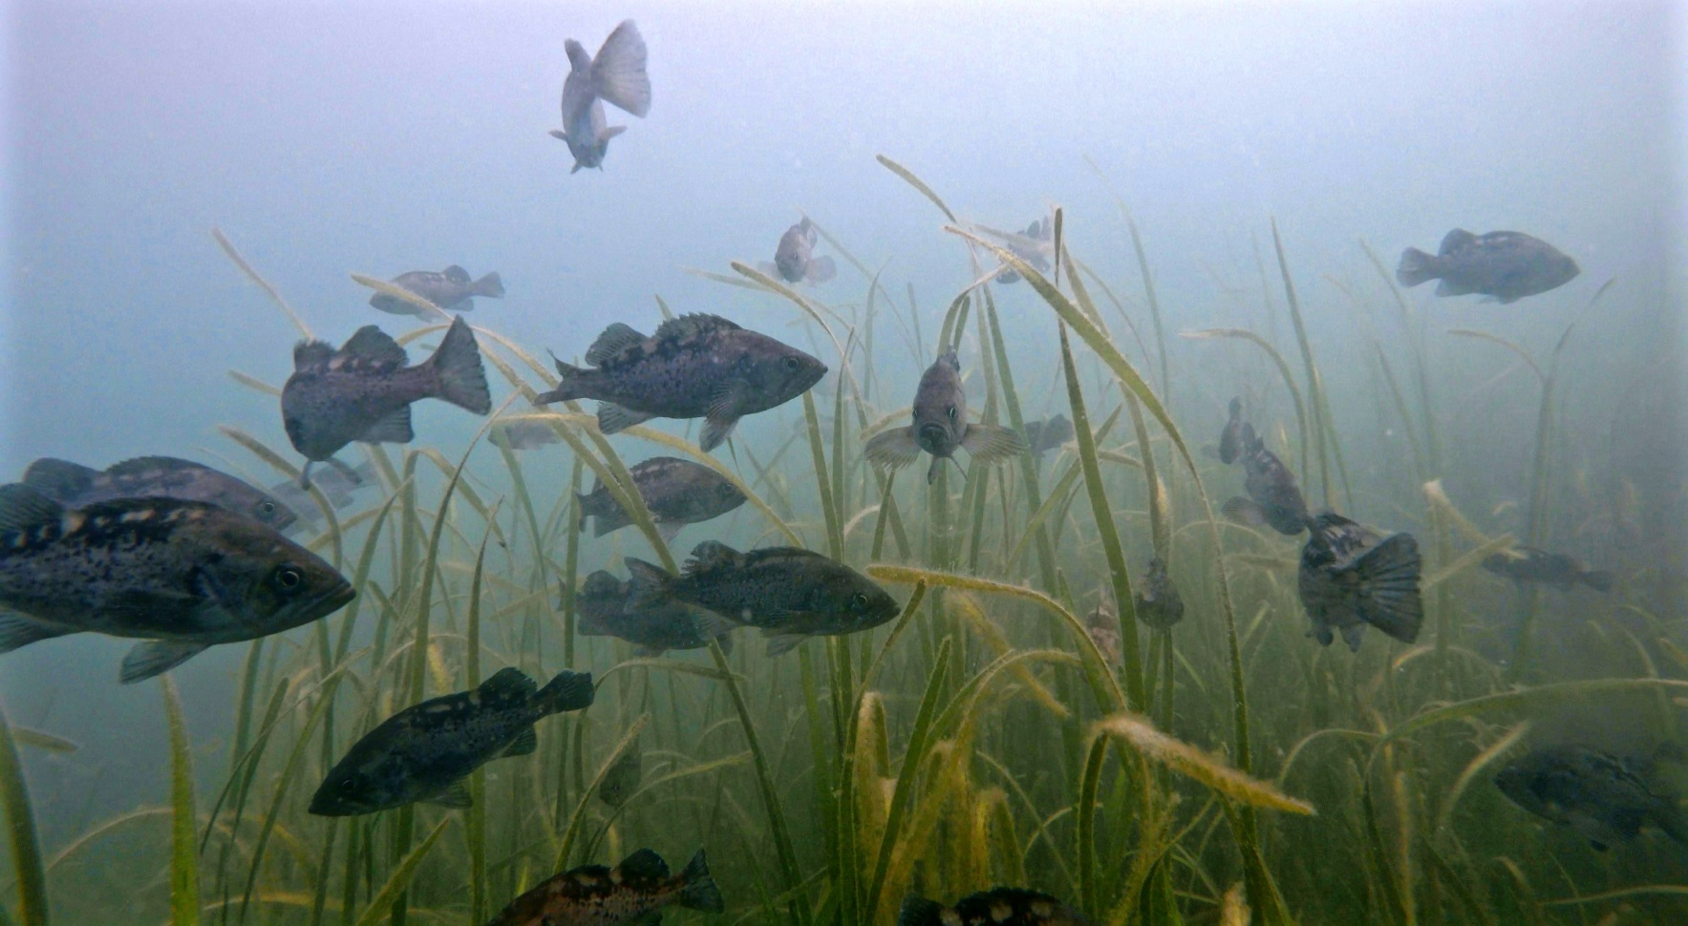

**Thank you for contributing to our metadata folder. Please submit this form along with any supporting documents to catalogue-team@hakai.org**

After submitting the form, the Hakai technology team will follow up with you to create a metadata record in our online library at [hecate.hakai.org/geonetwork](https://hecate.hakai.org/geonetwork/srv/eng/catalog.search#/home)